1. What is software? What is software engineering?

Software refers to a collection of programs, data, and instructions that enable a computer system to perform various tasks or operations.

It encompasses the entire set of instructions, programs, and data that enable a computer to perform specific functions or tasks.

Software engineering:

Software engineering is a discipline that involves applying engineering principles to the design, development, maintenance, testing, and evaluation of software and systems. It encompasses a systematic and structured approach to creating high-quality software products efficiently and reliably

2.Explain types of software

● Application software

● System software

● Driver software

● Middleware

● Programming software

3 What is SDLC? Explain each phase of SDLC

The Software Development Life Cycle (SDLC) refers to a methodology

with clearly defined processes for creating high-quality software.

1. Requirement Gathering

2. Analysis

3. Designing

4. Implementation

5. Testing

6. Maintenance

4. What is DFD? Create a DFD diagram on Flipkart.

DFD stands for Data Flow Diagram. It's a graphical representation of the flow of data within a system, illustrating how data is input, processed, stored, and output

DFD diagram of flipkart

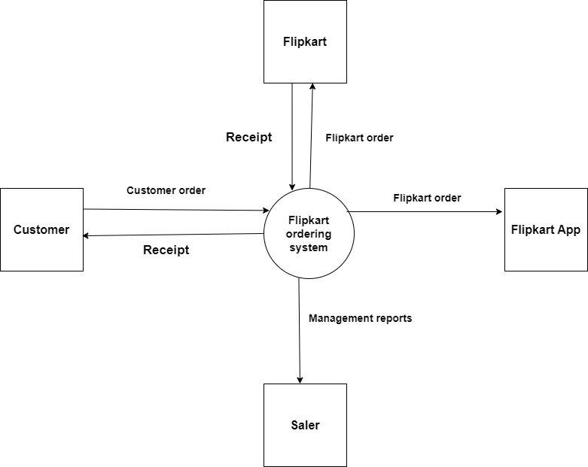

5. What is Flow chart? Create a flowchart to make addition of two numbers

A flowchart is a diagram depicting a process, a system or a computer algorithm. It is a diagrammatic representation of the solution to a given problem but, more importantly, it provides a breakdown of the essential steps to solving the problem.

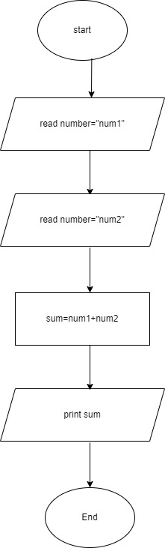

6. What is Use case Diagram? Create a use-case on bill payment on paytm.

A use case diagram is a graphical depiction of a user's possible interactions with a system. A use case diagram shows various use cases and different types of users the system has and will often be accompanied by other types of diagrams as well. The use cases are represented by either circles or ellipses. The actors are often shown as stick figures.

